SLUM DWELLERS EVALUATION OF UPGRADED SLUMS IN LAGOS METROPOLIS, NIGERIA

Adedayo, A.Fand Malik, N.A.
Department of Geography and Environmental Management,
University of Ilorin, Ilorin.

ABSTRACT
This paper examines slum residents’ evaluation of the impact of slum upgrading programmes in the nine (9) upgraded slums of Lagos Metropolis. Seven scales of measurement structured around percentage number of respondents having access to improved water source, refuse disposal method, health, education, electricity supply and improved road construction and percentage number of residents whose building were no longer affected by flood were used as the basis of evaluation. The study revealed that 44.4%, 53.6% and 49.3% of the respondents respectively claimed to have access to improved water source, education and health while 54% claimed that their buildings were no longer prone to flood after slum renewal. Also, the average rating of the upgrading programmes by respondents’ indicated 74.2% for improved road construction, 83.3% for better method of refuse disposal and 77.7% for improved electricity supply. The study thus concludes that any understanding of the slum redevelopment should incorporate slum dwellers assessment.
Keywords: Upgraded, Slums Evaluation, Slum Dwellers, Lagos, Nigeria

INTRODUCTION

A great challenge facing the Lagos Metropolis is shelter, particularly for people living in overcrowded slums (Abiodun, 1976).This results from its proportionate growth of about 230,000 to 1,136,000 between 1950 and 1963 (Mabogunje, 1968) to over 9 million in 2006 (Census, 2006). The average population density for Nigeria is about 85 persons per square kilometre. Lagos state with a population density of 1,308 persons per square kilometre is fifteen times higher than the whole country with available land falling prey to unregulated and unplanned development. To meet the housing requirement of the ever-increasing population, Lagos state is expected to provide 20,000 additional housing units per year by the year 2015. Despite housing shortages in Lagos metropolis,slum demolition has been the usual practice of past administration in Lagos state. This situation has increased housing shortages and the number of slums with present figure of over fifty slums spread across the state (UN-HABITAT, 2003). To reduce the challenges faced from slum demolition, Onokerhoraye (1988) suggested citing 1960 Lagos case that total clearance of slums could be expensive and unlikely to be effective. Slum control, reduction or eradication therefore constitutes a major task of governments, policy makers, planners and slum residents. This is because, the UN 2004/2005 Declaration as reported in Francoise (2006) to improve poverty and housing conditions of 100 million slum dwellers cannot be achieved solely through slum demolition.
Recently, slum upgrading had received the attention of the Lagos State government at various times through renewal programmes. The common practice of demolition of the slum environment exemplified by the Maroko case of 1990 has not succeeded in preventing the proliferation of slums. The findings of Agbola and Jinadu (1997) indicated that the life of the evictees were worse off in the relocated sites than Maroko since only 2,993 out of 41,776 landlords were relocated. Indeed, most victims of demolition were neither resettled nor compensated in line with the agitation of Non-governmental Organizations such as Social and Economic Rights Action (SERAC) and Centre on Human Rights and Evictions (COHRE) to defend the plight of the victims of eviction.
The slum upgrading programmes in Lagos metropolis involved public-private intervention which started with pilot upgrading at a cost of N314 million (US$ 2.0 million) in Badia under the 1995 Lagos Drainage and Sanitation project. This served as a feasibility test of developing an upgrading program in Lagos metropolis. The results of the feasibility test in Badia slum with support from Norwegian Government in 2001 showed that construction and rehabilitation of drains and community facilities had greatly improved the living conditions of slum residents. The success recorded in Badia prompted the Lagos state government and Lagos State Urban Renewal Board in 2002 to select nine (9) out of the fourty-two identified slums in 1984 for upgrading.
However, Lagos State Government with a focus of building the capacity of state and local government staff in consultative planning embarked upon intense participatory process to identify community needs and priorities. The upgrading experience from Nigeria and other parts of the world was considered in planning the slum upgrading intervention. Therefore, Lagos state government set a target of US$ 30,000 per hectare in order to elicit information on the basic infrastructural facilities required by the slum areas. The interactive process involved the full participation of all the necessary stakeholders in the slum upgrading programmes. In all, eighty-three (83) stakeholders consultative, nineteen (19) community level meetings, sixteen (16) working sessions with local governments, two urban fora in addition to various meetings with senior state officials were conducted before the subprojects proposals were finalized. The community demands were further turned to plans by local engineers and planners which were shared with the state, local government and the slum communities to ensure a clear and shared understanding among the different stakeholders. This implied that the final proposal reflect a clear agreement between the slum communities’ preferences, feasible options in terms of availability of land, financial constraints and the adoption of standards that is contiguous to each slum area. The slum residents’ evaluation of slum upgrading programmes as an alternative urban renewal approach therefore constitutes the rationale for this study.

STUDY AREA
The upgraded slums in metropolitan Lagos are the focus of this study. Lagos State is located in the south-western part of Nigeria. It lies approximately between longitudes 2⁰ 42’E and 3⁰ 42’E and latitudes 6⁰22’N and 6⁰52’N. The total land area is 3,577 square kilometers representing 0.4 percent of the entire area of Nigeria. Lagos State comprises 20 local government areas (LGAs) with the metropolitan covering 16 LGAs. There are 1,620 hectares of land covered by the 42 slums identified by United Nations study of 1984 which employed thirty-six indicators to measure access to basic infrastructural and social services. However, with the support of Norwegian Government and International Development Association, the Lagos State Government through its agency called Lagos Metropolitan Development and Governance Project (LMDGP) has upgraded nine (9) out of the forty-two identified in 1984. The nine slums covered 760 hectares representing 46.1 percent of the total number of slums (see Figure 1). Table 1 presents the percentage hectares of land covered by each slum area upgraded in the study area. Ajegunle slum area had the largest area representing 27.4 percent while Amukoko had the smallest with 5.4 percent. Badia had the second (2nd) largest area representing 17.4 percent. Others include Bariga (8.4%), Itire/Ijeshatedo (8.3%), Iwaya (9.0%), Makoko (9.5%), Ilaje (7.6%) and Agege (7.1%). The amount invested on each slum varies based on the scale of the projects.

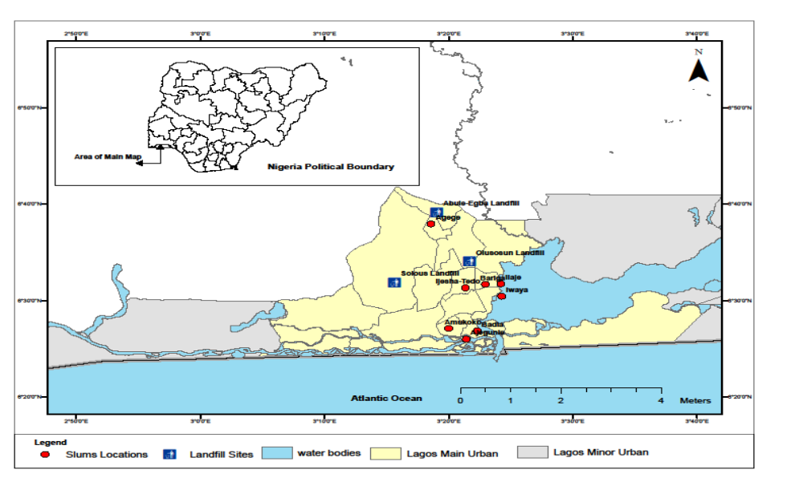

Figure 1: Upgraded slums in Lagos metropolis
Source:Produced by cartography section, Geography& Planning Department, Lagos State University

Table 1: Upgraded slums in Lagos metropolis
Slum area | Area in Hectares | Percentage
Agege | 54 | 7.1
Ajegunle | 208 | 27.4
Amukoko | 41 | 5.4
Badia | 132 | 17.4
Bariga | 64 | 8.4
Ilaje | 58 | 7.6
Itire/Ijeshatedo | 63 | 8.3
Iwaya | 69 | 9.0
Makoko | 72 | 9.5
Source:Stoveland Consultant, 2002

MATERIALS AND METHODS

Data used for this study were sourced through primary and secondary sources. The primary data was sourced through questionnaire administration. The data focused on respondents’ responses to questions about their evaluation of the upgraded slums in Lagos metropolis. Three scales of measurement developed by the Lagos State Government to determine the extent of success in the upgraded slum areas were restructured into seven scales for the purpose of this study. These are: Percentage number of slum residents with access to safe water such as tap water and borehole; Percentage number of slum buildings that were no longer prone to flooding; Percentage respondents rating on improved level of environmental cleanliness through access to refuse disposal vehicles; Percentage respondents rating on improved access through road construction; Percentage number of residents’ attendance of government hospital during sickness; Percentage respondents rating of regular supply of electricity; and Percentage enrollment of residents’ children in public schools.
Nine (9) out of 42 slums representing 21.5% which were currently upgraded through assistance from International Development Association and the World Bank were selected. Purposive sampling technique was employed to determine the sample size for the study. The technique was particularly chosen because of the unavailability of population data on ward basis and for the identified slums in Lagos metropolis. One thousand and eighty (1,080) respondents were selected through systematic-random technique with one hundred and twenty (120) questionnaires administered in each slum area. The distribution of the questionnaires in each of the slum started by pure random selection of the first house to determine the starting point from which the administration of questionnaire proceeded at an interval of five houses. The secondary data were sourced from Lagos Metropolitan Development and Governance Project (LMDGP), Lagos State Urban Renewal Authority (LASURA) to determine the type and scale of projects in each as well as the level of implementation in each slum. The data generated were analyzed using tables, simple percentages and graphical illustration to show the respondents evaluation of the upgraded slums in Lagos metropolis.

ANALYSIS AND DISCUSSION OF FINDINGS
The discussion of findings will be discussed under the following subthemes: respondents’ assessment of condition of slum areas, access to improved water source, reported flooding of residential building and improved access through road construction as well as accessibility to health and educational facilities in the upgraded slum areas.

Respondents’ Assessment of Condition of Slum Areas
Based on the objective of this paper, respondents were asked to rate the level of access roads, improved environmental cleanliness and regular electricity supply before and after renewal as either above average, average and below average. Table 2 reveals that 466 (43.1%), 636 (58.9%) and 476 (44.1%) of respondents respectively rated the level of improved road access, environmental cleanliness and electricity supply before renewal below average while the rating after renewal revealed that 278 (25.7%), 177 (16.4%) and 241 (22.5%) of respondents respectively rated it below average. In addition, the respondents rating of the level of access to roads, environmental cleanliness and electricity supply after renewal improved by 17.3%, 41.9% and 21.8% respectively (see Table 2). The implication is that lives of the residents of upgraded slums had been improved upon through the renewal programmes of the state.

Table 2: Respondents assessment of condition of slum areas
Rating | Access to Road | Environmental Cleanliness | Electricity Supply
Before Renewal  Above average  Average  Below average | 0 (0%)  614 (56.9%)  466 (43.1%) | 0 (0%)  444 (41.4%)  636 (58.9%) | 0 (0%)  604 (55.9%)  476 (44.1%)
After Renewal  Above average  Average  Below average | 03 (0.3%)  801 (74.2%)  278 (25.7%) | 0 (0%)  900 (83.3%)  177 (16.4%) | 0 (0%)  839 (77.7%)  241 (22.3%
Source:Author’s Fieldwork, 2012

Access to improved water source
The Lagos state is to provide 69 boreholes points and pipes which covers11.3km in the upgraded slums through LMDGP. In all the slum areas, 43 borehole points representing 62.3% had been provided to increase residents’ access to improved water source (see table 3).
Two sources of water were employed to determine respondents’ evaluation of accessibility to improved water source in the upgraded slums of Lagos Metropolis. These are: Treated water that is transferred into various houses by the State government on a prescribed monthly user’s fee. The second is the borehole provided by the State government through its Agency called Lagos Metropolitan Development and Governance Project (LMDGP), the community or non-governmental organization as well as private individuals who sell to residents of the slum at a fixed rate.

Table 3: Level of implementation on provision of improved water source
Slum Areas | Required | Implemented | % Level of implementation
Agege | 12 | Na | Na
Ajegunle | 12 | 3 | 25
Amukoko | 1.5km pipe | 1.5km pipe | 100
Badia | 13 | 8 | 61.5
Bariga | 2.3km pipe | Na | Na
Ilaje | 5km pipe | Na | Na
Itire/Ijeshatedo | 20 | 20 | 100
Iwaya | 6 | 6 | 100
Makoko | 6 | 6 | 100
Total | 69 | 43
Source:Lagos State Urban Renewal Authority (LASURA), 2012

As revealed in figure 2, four slums were identified by respondents as having access to improved water source in all the upgraded slums. These were: Iwaya (66.7%), Ajegunle (65.0%), Bariga (57.5%) and Badia with 50.0% respectively. However, in Agege, Amukoko, Itire/Ijeshatedo, Ilaje and Makoko, water from water vendors and dugged well were common. The figures were 78.3, 64.2, 62.5, 55.8 and 57.5% respectively.

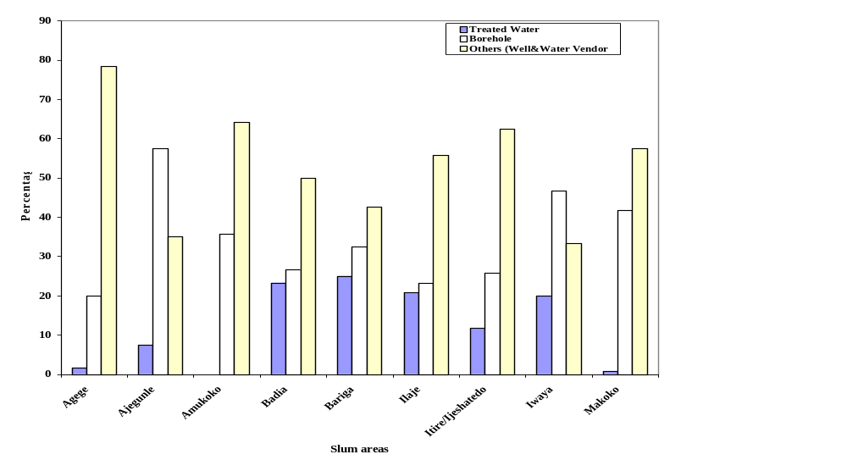
Figure 2: Respondents access to improved water source in the slum areas
Source:Author’s fieldwork, 2012
Reported Flooding of Residential
Environment and Improved Access
through Road Construction

Lack of drainage facilities influence greatly the flooding rate in the slums. This is because of the inability of waste or rain water during rainy season to flow freely. Figure 3 indicated that a remarkable success was achieved in five upgraded slums where flooding had been greatly reduced. These slum areas were Amukoko, Ajegunle, Itire/ijeshatedo, Badia and Ilaje where respondents reported that 86.7%, 83.3%, 65.8%, 57.5% and 54.2% of buildings were no longer affected by flooding. The reason for the success achieved in the slum areas was due to massive construction of roads accompanied by drainages (see plate 1).
Movement on land through transport is facilitated by the provision of good road network through the construction of new roads and rehabilitation of damaged ones. The slum residents were asked to rate improved access in their neighbourhood after road rehabilitation. As revealed in Figure 4, there were remarkable improvements in access in the slum areas of Amukoko, Itire/Ijeshatedo among others.
In addition, out of 51.3km of roads to be constructed in the slum areas, 31.58km representing 61.56% had been provided by LMDGP (see table 4).

Table 4: Level of implementation on road construction and rehabilitation
Slum Areas | Required (Km) | Constructed (Km) | % Level of Implementation
Agege | 5.0 | Na | Na
Ajegunle | 13.9 | 3.62 | 26.04
Amukoko | 4.4 | 4.4 | 100
Badia | 6.0 | 3.64 | 60.6
Bariga | 2.5 | 2.5 | 100
Ilaje | 2.6 | 1.37 | 54.8
Itire/Ijeshatedo | 8.7 | 8.7 | 100
Iwaya | 4.1 | 3.78 | 92.2
Makoko | 4.1 | 3.59 | 87.6
Total | 51.3 | 31.58
Source:Lagos State Urban Renewal Authority (LASURA), 2012

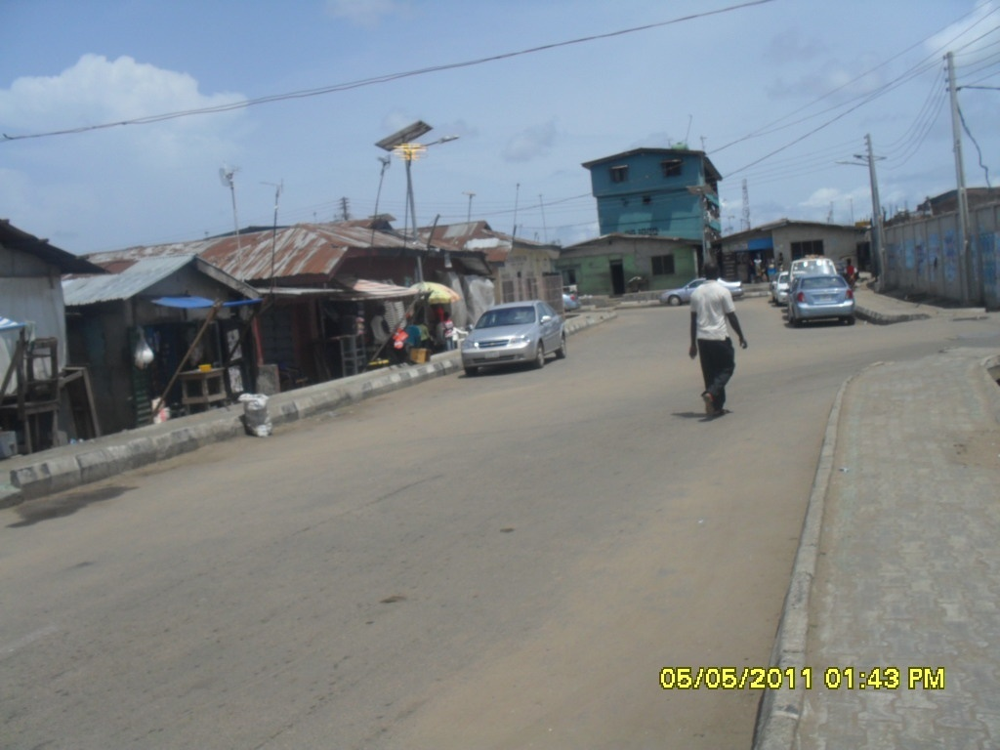
Plate 1: Dispensary Road at Badia constructed by LMDGP

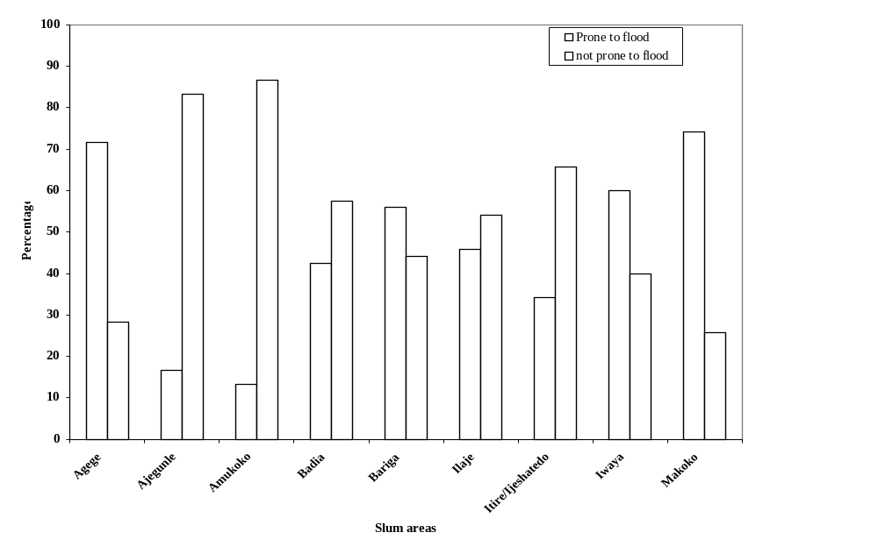

Figure 3: Respondents assessment of flooding of residential building in the slum areas
Source:Author’s fieldwork, 2012.

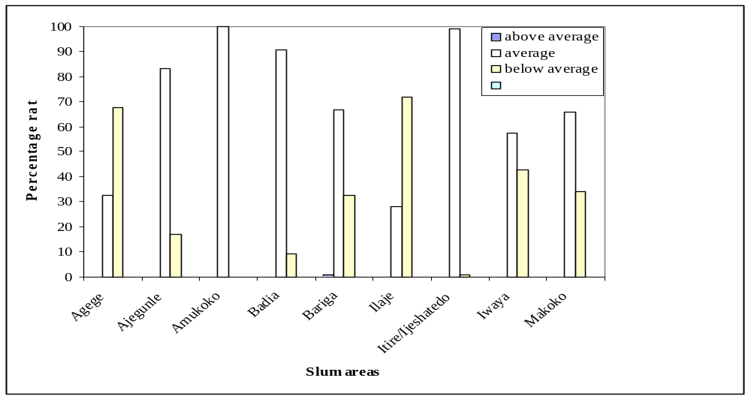
Figure 4: Respondents rating of improved access in the slum areas
Source: Author’s fieldwork, 2012

Accessibility to Health, Education and
Electricity Facilities

The accessibility to health institutions such as general hospitals and health centres are necessary to the well-being and health status of citizens in a country. This is because; these institutions provide medical services to people during sickness. Therefore, the respondents were asked question relating to accessibility to government provided hospitals during sickness. The accessibility of respondents to government health facilities revealed 70.8%, 53.3%, 80% and 70.8% for Agege, Ajegunle, Amukoko and Badia upgraded slums respectively (see figure 5). This is expected because of the comprehensive health programme embarked upon by Lagos state government. For instance, there are free medical services provided for certain age-groups, pregnant women and free eye glasses among others which did not exclude residents of the slum areas.

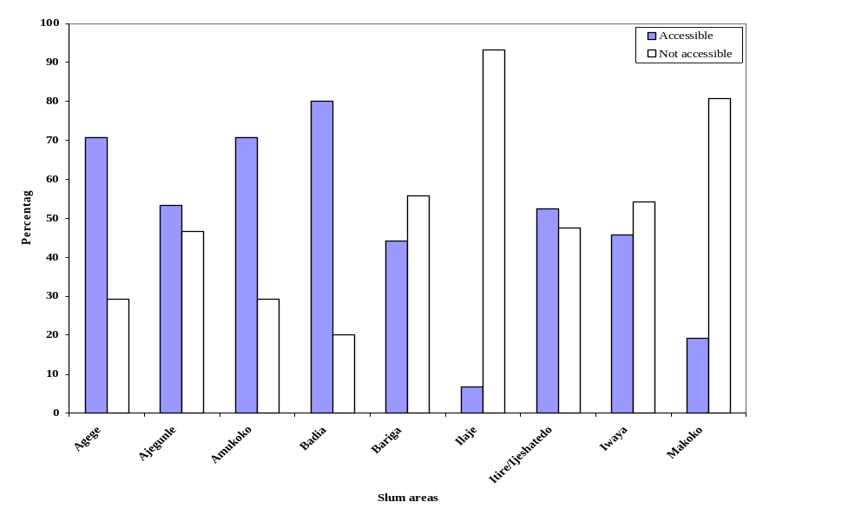Figure 5: Accessibility of respondents to health facility in the slum areas
Source:Author’s fieldwork, 2012

Table 5 revealed that out of eleven (11) health centres either to be constructed or rehabilitated, six (6) representing 54.5% had been completed. These include two (2) health centres rehabilitated in Badia and Makoko slums while a new health centre was provided for Ilaje and Itire/Ijeshatedo.

Table 5: Level of Implementation for provision of health centre
Slum Areas | Required | Implemented | % Level of implementation
Agege | Na | Na | Na
Ajegunle | 2 | 0 | 0
Amukoko | 1 | 0 | 0
Badia | 2 | 2 | 100
Bariga | Nr | Nr | Nr
Ilaje | 1 | 1 | 100
Itire/Ijeshatedo | 1 | 1 | 100
Iwaya | 2 | 0 | 0
Makoko | 2 | 2 | 100
Total | 11 | 6
Source: Lagos State Urban Renewal Authority (LASURA), 2012 Na: Not available; Nr: Not required

Prior to the emergence of private primary, secondary and tertiary institutions, public educational institutions predominated in Nigeria. Public secondary schools were available in all the upgraded slums. Figure 6 further revealed that child enrolment at government schools were remarkable in the slums of Agege, Ajegunle, Amukoko, Badia, Itire/Ijeshatedo and Iwaya with 80, 67.5, 69.2, 77.5, 57.5 and 64.2% of respondents respectively indicated children access to education facility. In addition to the existing ones, six (6) newly constructed schools and twenty-one are for upgrading. The field survey revealed that three (3) new schools had been constructed and eleven (11) schools rehabilitated representing 50% and 52.4% level of implementation respectively (see Table 6 and Plate 2).

Table 6: Level of Implementation for School construction/rehabilitation
Slum Areas | Required  new rehabilitated | Implemented  new rehabilitated | % Level of Implementation
Agege | Nr | Nr | Nr
Ajegunle | 2 3 | 3 | 60
Amukoko | Nr Nr | Nr Nr | Nr
Badia | Nr 4 | 4 | 100
Bariga | 1 4 | 4 | 80
Ilaje | 1 4 | 1 0 | 20
Itire/Ijeshatedo | 2 Nr | 2 Nr | 100
Iwaya | Nr 4 | 0 | 0
Makoko | Nr 2 | 0 | 0
Total | 6 21 | 3 11
Source:Lagos State Urban Renewal Authority (LASURA), 2011 Nr: Not required

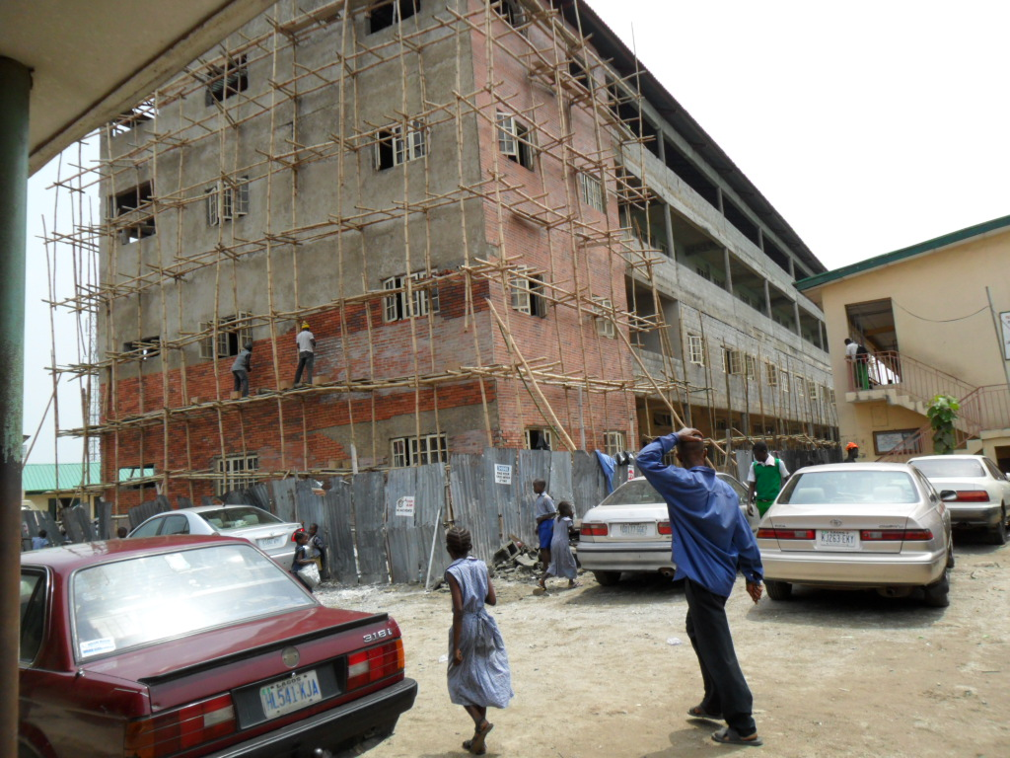

Plate 2: Fazl Omar School under construction at Iwaya by LMDGP

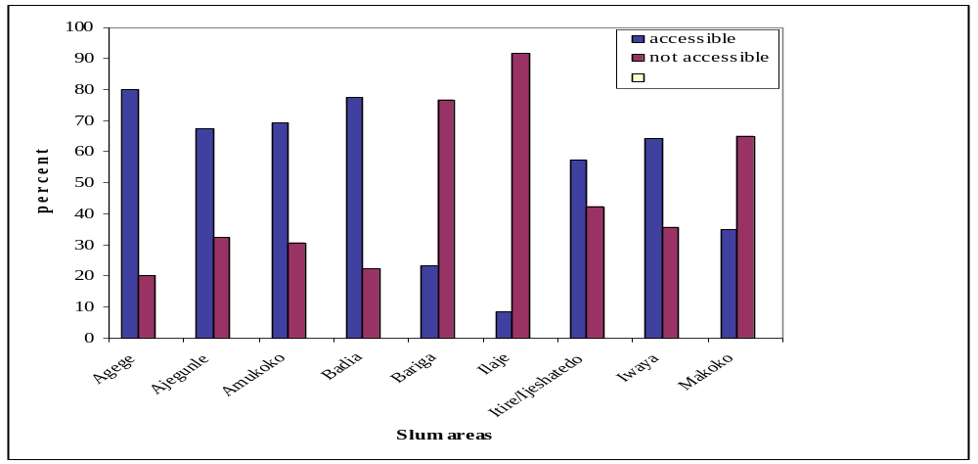
Figure 6: Accessibility to education facility in the slum areas
Source:Author’s fieldwork, 2012

The slum residents’ evaluation of regular power supply through provision of additional transformers by LMDGP indicated that 80, 85.8, 88.3, 60.8, 60.7% of respondents in Agege, Bariga, Ilaje, Itire/Ijeshatedo and Iwaya respectively rated the efforts of government as average (see fig.7)

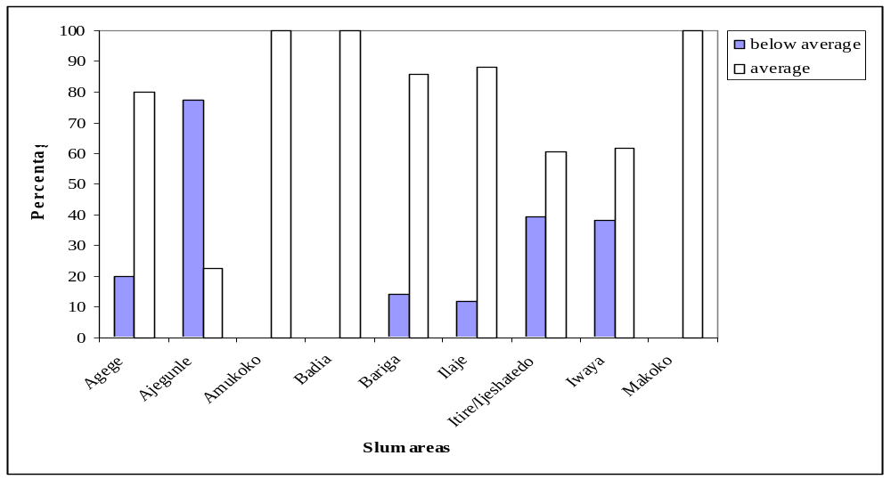
Figure 7: Respondents rating of regular supply of electricity
Source:Author’s fieldwork, 2012

CONCLUSION AND IMPLICATION

This study has established from the slum residents perception and level of implementation of the upgrading programmes that on the average, almost half of the slum residents in the upgraded slums have better access to improved water source, education and health facilities provided by Lagos state agency called Lagos Metropolitan Development and Governance Project. The study also reveals an improved rating of respondents from 56.9% to 74.2%, 41.4% to 83.3% and 55.9% to 77.7% for access to road, improved environmental cleanliness and regular supply of electricity respectively. These results are linked to the level of completion achieved in the slum upgrading programmes required in the nine (9) upgraded slums in Lagos metropolis. Therefore, this study has revealed the impact of planning with the slum residents in the process of upgrading the slums. This study thus recommends that slum upgrading programmes in slums should be sustained, encouraged and incorporated into Lagos state policy and beyond.

REFERENCES

Abiodun, O.J. (1976). Housing problems in Nigerian Cities.Town Planning Review.47(4): 330-348
Agbola, T. and Jinadu, A.M. (1997):”Tenants addressing the needs, increasing options” In Environment and Urbanization, 9 (2): 271-289.
Francoise Lieberherr-gardiol (2006) Slums forever? Globalisation and Its Consequences.TheEuropean Journal of Development Research, 18(2): 275-283.
Mabogunje, A.L. (1968) Urbanisation in Nigeria, University Press London.
Onokerhoraye, A.G. (1988) “Case studies of urban slums and environmental problems in Nigerian Cities”.inSada, P.O. and Odemerho, F.O. (eds.) Environmental Issues and Management in Nigerian development. Evans Brothers.Pp 118-131.
UN-HABITAT (2003).The Challenge of Slums: Global report on human settlements. London, Earthscan Publications Ltd.

